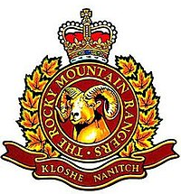
Welcome 2618 Rocky Mountain Rangers Royal Canadian Army Cadet Corps!

The officers, volunteers and sponsoring committee welcome you to one of the oldest continuously active Cadet Corps in British Columbia. Your decision to become a member of 2618 RCACC is a big one. As a Cadet you will have the opportunity to challenge and push yourself, as well as the opportunity to advance and figure out who you really are. Some of the opportunities we offer are the opportunity to get your Parachute jump wings, Field Training Exercises, Expedition trips, canoeing, Mountain biking, Absail, free summer camps in British Columbia and across the country, the Duke of Edinburgh program, zone, provincial and national sports competitions such as Biathlon and marksmanship, medals, awards, and school credits just to name a few.
Being a Cadet is a privilege that should not be taken lightly. The staff of 2618 RCACC are committed to making the Cadet program the very best it can be and want you to know that we are an extremely dedicated group of qualified instructors, coaches, and team leaders. We expect each Cadet to make the commitment, taking an active part in the program, achieving all that they can achieve in the Cadet Training Program.
Enjoy your time with the cadet movement and strive to achieve everything that we have to offer

Meeting Times: Wednesdays
Doors open 6:00pm
Fall in parade 6:30pm
Instruction 7pm-855pm
Dismissal parade 9-915pm (Parent Pickup)

KIT ENTITLEMENT
Dress Uniform (Commonly called DEUs):
Beret(w/badge) | 1
Tunic (with standard badges and belt) | 1
Green T Shirt | 1
Trousers | 1
Gold Belt for pants | 1
Grey Socks | 2(pr)
Parade Boots | 1(pr)
Gloves | 1(pr)
Parka w/Fleece Lining (3 in 1) | 1
RCACC Toque | 1
Field Training Uniform (top and pants) | 1
Combat Boots | 1pr

Department of National Defense approves and issues on loan, completely free of charge, the uniform worn by Army Cadets. The care of all items of clothing issued are the responsibility of cadets and their parents or guardians.
The dress and appearance of Army Cadets in or out of uniform will be such to reflect credit to their unit and the Royal Canadian Army Cadets. The uniform is to be worn only when attending authorized parades or activities. When cadets appear in uniform in public, it is their duty to be sure that their uniforms are properly maintained and correctly worn.
SUGGESTED PERSONAL KIT
While cadets are issued a number of clothing items there are a fair number of items the Cadet Organization does not supply. This is a list of items we suggest cadets should typically have. These items will be used on Field Training Exercises, and other events
***We are not looking for them to have top of the line name brand things and often during an exercise cadets are prone to losing or damaging their personal kit. We suggest getting economical items that will do the job. We are also aware that many are unable to afford these items and the main items are available for loan.
Item | Qty | Item | Qty
Backpack or duffel | 1 | Notebook or binder | 1
Hiking Boots | 1pr | Pen/pencil | 3
Winter weight coat | 1 | Watch | 1
insulated winter Boots | 1 | Windbreaker/rain coat | 1
Winter weight (skidoo/ski) pants | 1 | Wind pants/rain pants/splash pants | 1
Track/sweat pants (fleece) | 2 | Shorts | 1
Long Underwear | 2 | T-shirt | 1
Sweatshirt (Fleece) | 2 | Flashlight | 1
Long-sleeve T-shirt | 2 | Sleeping Bag and Mat | 1
Mittens/Gloves (High Thermal Value) | 2 | Toque or hat | 1
Sneakers/running shoes (NOT skater type) | 1 | Sunscreen & Bug spray | 1
Water Bottle | 1 | Sunglasses | 1
Hygiene Kit (See Below) | 1

Toothbrush & Toothpaste | Feminine Hygiene items
Deodorant (Not body spray) | Chapstick
Hairbrush | Shaving gear as needed

Being a part of a Cadet Corps

The Canadian Cadet Organization(CCO) is a youth program dedicated towards developing leadership and citizenship in youth that emulates a military style structure in training and delivery.
Throughout your training, you will learn to follow and work with your peers in order to gain an understanding of the basics of leadership, which will eventually entail becoming a leader yourself. With this in mind it’s important to note that not only will your leaders be compromised of adult staff (military personnel and Civilian Volunteers (CV) but other cadets such as yourself; treat them with the respect that you wish to be treated with.

Cadet Staff: Officers are members of the Cadet Instructors Cadre (CIC). They are members of the Reserve Forces of the Canadian Armed Forces. Other civilian staff can include Civilian Instructors (CV and Civilian Volunteers. All staff have undergone background screening and some level of training for the program.

Regular Training Nights: The majority of your time in cadets will take place on Wednesday night from 615 pm to 915 pm, the upstairs door to cadet hall will be unlocked by 6pm, please do not leave your cadet alone, wait until there is an officer present.
After arriving your night will consist of first parade, during which you will be inspected by the Platoon Commanders or an officer. After the parade you will then have three 30 minute classes with 5 minute breaks in between, after second period there will be a canteen (cadets may spend up to $2/night). Shortly before 9pm, you will fall in for final parade, information and letters home maybe dispersed and announcements made, and then you will be dismissed to go home. Cadets must have a pickup no later than 915pm.

Promotions & Advancement: During the course of your training, you will become qualified to be promoted up through the various ranks from Private all the way up to Chief Warrant Officer. Although each rank has its own perquisites that must be met before a cadet can be promoted, cadets must also prove themselves mature, reliable and capable of fulfilling the duties of the rank. When it comes to the senior ranks (Sergeant and above) there is the additional condition of number of available spots for each rank.

Misbehavior
Discipline & Dismissal: The cadet organization has an established policy on how to deal with disciplinary issues, CATO 15-22 outlines that all disciplinary actions be administered with procedural fairness to assist the individual’s growth. Serious infractions will follow a 3 Strike policy (Verbal, Written, Dismissal), parents will be informed if any of these actions are taken. We will be in contact with parents/guardians before it gets to this point.
Fraternization: During training and cadet functions there will be no fraternization tolerated between cadets. Cadets unable to follow this will be subject to the guidelines state above.
Bullying: The Cadet organization has a Zero Tolerance policy on bullying; all cadets have the right to feel safe and welcome. All cadets are required to report any instance of behavior they feel is Bullying or Harassment.
Sexual Harassment/Abuse: All accusations of Sexual Harassment or Abuse will be reported to the proper authorities and up our Chain of Command.
Prohibited Actions: As cadets must be between the ages of 12-18, no cadet member is of legal age to smoke, vape, or drink alcohol. Any cadet found smoking or in possession of smoking items will have those items confiscated and be sent home. Cadets found in possession or under the influence of alcohol, non-prescription or illegal drugs will be reported to the proper authorities and subject to dismissal from the Cadet Program.
Child Protection: Members of the Cadet Instructor Cadre (CIC) are obligated to report to the proper authorities if any cadet discloses being abused emotionally, physically or sexually within the Cadet Program or domestically.
Young Offender: Any child enrolling in the cadet program for rehabilitation purposes as ordered by the Justice system will need to inform the CO of the general nature of the offences. Any and all information divulged will remain confidential; these cadets will be treated with the same respect as the others. Youth undergoing investigation by the police may not parade until this has been resolved.
Quitting
If for any reason you feel the cadet program is not for you, we encourage you to speak to the staff to see if there is anything we can fix or assist with to help you have a more enjoyable experience through this program. It’s not uncommon for cadets to feel uneasy and shy away from being put into leadership roles, while leadership is a major component to the Cadet movement, we can work with you to accommodate your comfort level.
If you have decided to leave the cadet program we ask that you take the time to meet with the CO and have an exit interview before turning your issued kit back in to the Supply Officer. We will want to find out if the reason for leaving is due to something we can improve upon.

Returning Kit: When returning kit to the Supply Officer, it must be returned meeting the following criteria:
- All parts of the uniform must be returned clean
- All parts must be accounted for. The shirt, socks, and Wedge may be kept or disposed of.
- Labeled with name of the cadet returning the uniform
- Do not take uniform to a second hand store or leave it by the door of the Cadet Hall

Dismissal
In the unfortunate event that it has been deemed that your daughter/son has committed some offence or misdeed that warrants dismissal from the cadet corps exit procedures are the same as steps listed above in Quitting.
We will do all that is reasonably possible before it arrives at this step, cadets will be counseled and mentored on ways to improve their behavior.

Mandatory Training Information

Regular Training: Takes place every Wednesday evening 6:15-9:15 PM. Regular training is part of the MANDTORY training plan and it is imperative that your son/daughter be on time and participates in at least 60% of all regular training. Cadets may be cancelled if there is poor weather in this case the Facebook page and email list will be contacted.

Field Training Exercises (FTXs): Are part of the MANDATORY training plan and cover a multitude of activities best suited to an outdoor learning environment, such as Map and Compass skills. We have a minimum of one FTX per year and are usually comprised of a full weekend.

Training Days: Are scheduled periodically throughout the training year, they are part of the MANDATORY training plan, and may take place indoors e.g., Range Day or outdoors e.g., snowshoeing, usually to emphasize some particular skill. They may also be used to "catch up" on missed training due to winter storms or parade practices. This may also include Flying days.

Silver and Gold Star Expeditions Cadets in their 3rd year (Silver Star) and 4th year (Gold Star) must participate in an expedition in each of these years. They consist of travel to an expedition site somewhere in the province and general include hiking, camping, mountain biking and canoeing.

Remembrance Day Parade (Nov 11): Is a MANDATORY parade that the Corps participates in annually. Poppy distribution is also done prior to this.
Poppy Campaign: Each year, generally the two weekends prior to Remembrance Day, the cadets are required to participate in the Royal Canadian Legion’s Poppy Campaign, as a part of their Citizenship Training. The funds collected from handing out poppies is used by the Legion to support our Veterans and their families, and other community activities. Cadets will be required to serve a 2-3 hour shift depending on the number of shifts needing to be covered.

Annual Ceremonial Review (ACR): The ACR is part of Mandatory Training. Cadets must attend this event in order to complete their training level, receive any related rank promotions, and participate in summer training. This event is the opportunity for the cadets to display what they have learned over the past training year to their families and assembled guests. It is also the opportunity for the Corps to honor deserving cadets by presenting them with various awards. *Traditionally takes place in May or early June
Fundraising: Is an integral part of making sure that training remains interesting and fun for all cadets involved. Throughout the training year, cadets will be expected to take part in fundraising events that will benefit the corps as well as the community. Money raised will be used towards trips that aren’t covered by our typical training budget such as out of area trips and local unsupported activities. Parents can assist by getting involved with the Parent Sponsoring Committee.

Optional Training Information
Cadets must maintain an attendance of at least 60% in Regular Training to participate in optional training! If too few cadets participate, these activities will not take place. All activities will run only if an officer is available to host it.
Band: 2618 RCACC has been developing a pipe band for a few years. This includes use of bagpipes and drums along with traditional dress. The unit is looking for trainers and cadets to take part in this. There are also camps available in the summer
Biathlon: The biathlon training program consists of training cadets to compete in a number of winter biathlon competitions consisting of Nordic skiing and marksmanship.
The Zones competition takes place in January, with the provincial competition taking place in February. ***The biathlon coach will issue a kit list of additional personal items required.

Marksmanship: The marksmanship program consists of training cadets in proper prone and standing techniques. A marksmanship team consists of 5 cadets (minimum of 2 cadets under the age of 15). All cadets interested in joining the marksmanship team will be trained and coached during the training sessions until the team will be chosen based on overall shooting technique, scores, participation, and attitude. Marksmanship summer camps are available.

Orienteering: Using map and compass. Competitions available.
Equipment needed for optional activities is provided. Meals and accommodation are provided for out of town competitions.

Duke of Edinburgh: Is a long-standing non-competitive international award program for youth from ages 14-24. The award is about personal challenge and development; it is adaptable according to each participant’s interests and abilities. This program aims to deepen self-awareness, build confidence and broaden skills and experiences to further their growth as active, responsible citizens. This is an individual program that cadets go through with the help of the Duke of Edinburgh Leader.

First Aid: Practices and First Aid Training classes will take place through the year, sometimes leading to a competition.

Drill: If offered, drill sessions will lead to the development of a drill team.

Communication & Information

Platoons: One of the cornerstones of leadership is becoming self-sufficient. As cadets rise through the ranks they will become responsible for a section of junior cadets that they will be responsible for mentoring and passing along information about various things such as what the order of dress is, timings for events, and where to meet. This will serve as a way to ensure that the cadet is aware and has acknowledged the information.

Please do not contact the staff looking for information on upcoming events. Instead, have your daughter/son ask their Section Commander for further information. If the Section Commander doesn’t have an answer for you, allow them time to follow the Chain of Command.

Announcement wall: announcements and sign-up sheets will be posted on the wall in the headquarters each night/week as needed. Final announcements made on parade will also be placed here. It is the cadet’s responsibility to copy or take a photo of the announcements and inform their parents. Announcements will also be posted to the social media sites.

Email list: A member of the Parent Sponsoring Committee will take parent email addresses for routine contact about unit events

Facebook: Take the time to visit the Corps’ Facebook page by searching for “2618 Rocky Mountain Rangers Army Cadets” and like the page to get notifications on posts. We will be posting reminders for upcoming events, featuring cadet’s accomplishments, and posting pictures from events to this page.
Posting to the Facebook page does not guarantee a response. The Officers are not responsible for monitoring the page or answering questions, we will if and when able to do so.

Keep in mind that any post made to the page deemed inappropriate or of a personal nature (such as a conflict) will be removed and will not be responded to. In the event that you have an issue that you feel needs to be discussed, we ask that you either message the page or contact the CO.

Phone: The Corps phone is not answered other than Wednesday evenings. The voicemail is checked that night. Cadets can call in if they are going to be absent.

Absences, Cancellations, and Weather

Absences: If your daughter/son is going to be absent from any training events we ask that they contact their Platoon Commander and report their reason for why they will be absent or late. It is important for them to follow through reporting the reason for their absences as a cadet’s attendance record is heavily considered when it comes to things like promotions, expedition and camp applications, and appointments.
If there is a history of continuous unexplained absences, we will contact the parent/guardian to find out the reason for this. Cadets are required to maintain an attendance of a minimum 60% to pass their training level (along with meeting training standards).
In the event of an absence, the cadets themselves are responsible for finding out what they missed and to get caught up on any work or projects that are going to be due.

Cancellations: In the event we have to cancel a training activity due to training site issues, staffing issues, etc, we will do our best to post to the Facebook page and email list before anyone begins travelling to any training site.

Weather: As a standard policy, if school is cancelled, cadet training will also be cancelled. Also, we implore you to use your own judgment on whether your roads are safe to travel, even if we haven’t cancelled training. We understand that out of town roads don’t always get the same attention.

Orders of Dress
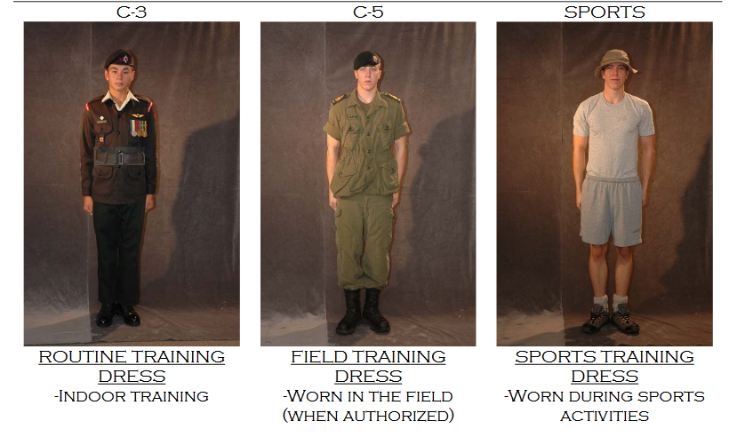
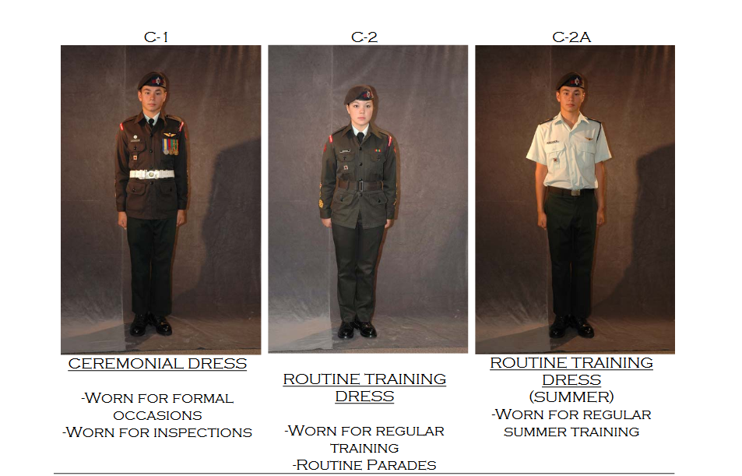

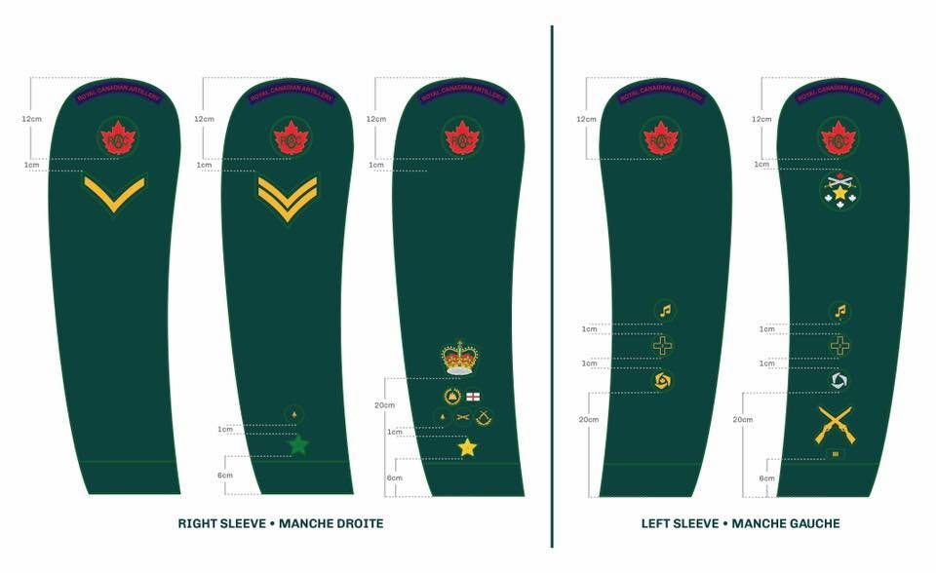

Deportment & Standards

The dress and appearance of army cadets in or out of uniform shall, on all occasions, be such to reflect credit to their unit and the Royal Canadian Army Cadets. The uniform is to be worn only when attending authorized parades or activities. When cadets appear in uniform in public, it is their duty to ensure that their uniforms are properly maintained and correctly worn. Refer to CATO 46-01 for army cadet dress. If it is not listed there, it is not permitted.

In addition, when wearing civilian clothing, it is to be of conservative style, neat, tidy, with properly hemmed pants/jeans, no frayed ends or holes, t-shirts free of vulgar or inappropriate advertising, waistbands worn at the waist and shirts worn either tucked in or long enough to cover midriff when arm is elevated over the head. Shirts with spaghetti straps or muscle shirts are not permitted.
- When in uniform you should present a good appearance.
- Chewing gum, slouching, hands in pockets, walking arm in arm, and similar actions do not look good for a cadet in uniform.
- Cadets are not permitted to hold hands or demonstrate public displays of affection while in uniform or at any cadet activity.
- Cadets are NOT permitted to smoke under any circumstances.
- The way you behave in uniform will affect what people think of all cadets. The pride you show in your uniform is a reflection of the pride you have in yourself, your Corps and your Country.
- Should a cadet decide that the program is not for them and they quit, it is the responsibility of the cadet to notify the CO and to return the uniform, in its entirety, immediately (within 14 days).

Female Appearance
Female cadets are authorized to wear a minimal amount of make-up. When in uniform, make-up shall be applied conservatively. This precludes the use of false eyelashes, heavy eyeliner, brightly colored eye shadow or lipstick, colored nail polish, and excessive facial make-up.
The only jewelry that may be worn in uniform shall be a conservative wristwatch, a medical alert bracelet and a maximum of two rings (one on either hand), which are not of a costume jewelry nature. In addition, female cadets in uniform may wear a single pair of plain gold, silver stud or white pearl earrings in pierced ears. The single stud earring, worn in the center of each earlobe, shall be spherical in shape and not exceed 0.6 cm in diameter. No other type of earring shall be worn except for a gold or silver healing device of similar shape and size, which may be worn while ears are healing after piercing. Only a single earring or healing device, worn in the center of each ear lobe, may be worn at a time.
Females are only permitted to wear clear nail polish or have a French manicure, all other colors are forbidden.
***Failure to abide by these standards will be addressed by putting the cadet on a Leave of Absence until the piercing is healed enough to be removed during training periods.
Female Hair Standards
Female cadets must follow the regulations outlined in CATO 46-01 Annex F for hairstyles. While in cadets, dying your hair an unnatural color or shade is not permitted.

Short Hair
 | Short hair  Hair cannot pass the lower edge of the shirt collar.
Long Hair
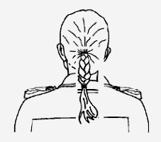 | Single Braid  Must be conservatively styled and tied tightly, secured at the end by an elastic or small, unadorned fastener.  Hair gel may be used  MUST not extend further than the top of the armpit!
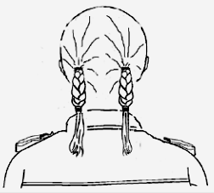 | Double Braids  Follow the same guidelines as above, must be worn behind the shoulders. Has the same length limitations as the single braid.
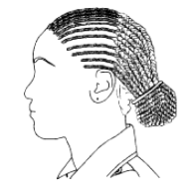 | Cornrows/Multiple Braids  Shall be directed toward the back of the head, pulled to the head and secured at the end by a knot, elastic, or small unadorned fastener.  *Any cornrow extending below the lower edge of the collar needs to be gather up into a bun
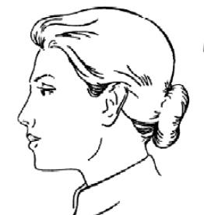 | Bun  Hair to be gathered neatly into a tight bun that sits just below where the Wedge would rest at the back of the head.  Gel or hair net may also be used
 | Hijab  For female adherents of the Muslim religion, subject to the requirements listed above, a civilian-pattern hijab may be worn under the headdress. The Hijab must be the color of the wedge worn by other cadets in the corps. When worn, it shall cover the hair and be tucked into the shirt collar.

Male Appearance
Male cadets are not permitted to wear ANY piercing what so ever. Males are also expected to have clean-shaven faces (or may grow a beard or moustache, if able, at the CO’s discretion) and haircuts that keep in line with the following standards:

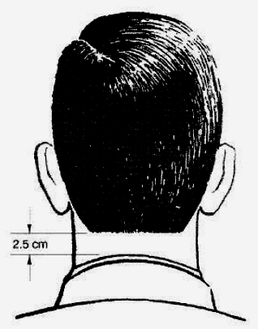 | Back  Male cadets are allowed to have their hair either squared (L) or tapered (R).  *There must be a 2.5cm gap between hair and collar. | 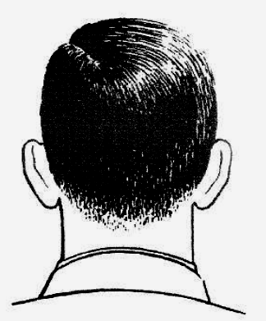
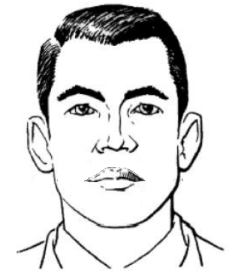 | Top & Side  Males are permitted to have hair up to 6 inches in length on top of their head, BUT must be groomed in case beret is removed.  Sideburns shall not extended lower a line bisecting the ear. Sides are to be tapered and not to touch the ears | 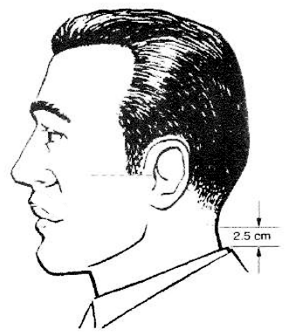  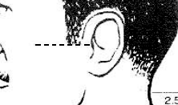

Religious Requirements & Other Special Circumstances
Only cadets adhering to the Sikh religion or cadets experiencing recognized medical problems preventing them from shaving may wear a beard. In the latter case, a note from a medical practitioner is required.
Those with First Nations heritage are authorized to grow their hair out to a proper length to be braided. Cadets seeking to do this must inform the CO of their intent and must tie their hair back during training until such time as it can be put into a single braid as shown below.

Tattoos
The policy regarding tattoos on cadets parallels the policy outlined in the CAF Dress Instruction,: tattoos are not to be on the hands, wrists, neck, head, or face. Tattoos deemed offensive or vulgar will remain covered up during all cadet activities, regardless of dress of the day.
Summer Training
Age Camp Duration
BASIC COURSES
12 General Training 2 weeks

13-14 Basic Musician 3 weeks
Basic Marksmanship
Basic Drill & Ceremonial
Basic Fitness and Sports
Basic Military Music
Basic Air Rifle

14-18 INSRUCTOR COURSES 6 weeks
Air Rifle Marksmanship Instructor
Drill & Ceremonial Instructor
Pipe Band Intermediate
Fitness & Sports Instructor
Military Band Intermediate
Survival Instructor
Expedition Instructor
Fitness Instructor

ADVANCED COURSES
16-18 6 weeks
Para
Leadership and Challenge
International Exchange
Advanced Musician
Fullbore Marksmanship
Staffing: also available for the full duration of summer camp period. Cadets are paid for working at the summer camp

ALL courses and transportation to and from are free of charge except for the purchase of a valid Canadian passport for those trips outside of our country. Applying for camp does not guarantee placement on the course of your choice. It is important for the parents to understand that selection for these courses are based on several things:

- Availability of courses given to the squadron
- Dress and Deportment
- Attendance and participation
- Physical & mental fitness
- Willingness of cadets to apply for said course/expedition and to take it upon themselves to prepare for it.
- Pass a selection board made up of instructors, officers, and possibly a member(s) of the Sponsor Committee.
- Only a limited number of slots are available for any given course; not all cadets who apply will be selected.
- Specialty course such as Marksmanship and Band will require cadets to prove their ability prior to acceptance.
What is the Chain of Command?
The Chain of Command is an order of hierarchy by which the military wields and delegates authority and power from senior Officers (COs) down to every member, at every level of the organization. By design, direction flows downward along the chain of command and accountability flows upward.

The chain of command is how information flows through the rank structure.
Example: The Squadron Commander has received a message from the CO that needs to be distributed to the cadets She will tell the Flt Comds, who will pass the information on to ensure each cadet is informed.

When you have a question or idea, make sure to pass it up the chain of command.
Example: Cadet Austria cannot remember where to report for this weekend’s FTX. First, he will ask Corporal Belgium for this information. If Cpl Belgium doesn't know the answer, Cpl Belgium will ask Sergeant (Sgt) Panama for the answer. If Sgt Panama is unsure, she will continue up the chain of command until the answer is found and sent back down the chain to Cadet Austria. Not all questions require the chain of command. Don't forget that your fellow cadets might be able to answer your question, check with them before using the Chain of Command.

Jumping the chain of command is a last resort. Be sure that you have talked to every other cadet, Corporal, Master Corporal before asking a Sgt and let them know that you have talked to all of these people before talking to them. A Junior NCO can answer most general questions. In a situation where the concern involves the Chain of Command it is acceptable to skip one link in the chain. (emergencies, violence, etc always involve officers!)

The following page depicts the Cadet Organization and 2618 RCACC Chain of Command (CoC):

Abbreviation Glossary
As the officers of 2618 RCACC are members the CF Reserves, we often use abbreviations and acronyms. The following are some more frequently used abbreviations you may come across:
2IC\DCO | Second In Command\Deputy Commanding Officer
ACR | Annual Ceremonial Review
AdminO | Administration Officer
CI | Civilian Instructor
CSM | Company Sergeant major
RSM | Regimental Sergeant Major
CAF | Canadian Armed Forces
CATO | Cadet Administrative and Training Order
CF | Canadian Forces
CIC | Cadet Instructor Cadre
CO | Commanding Officer
Plt | Platoon
CTC | Cadet Training Center
DofE | Duke of Edinburgh
FTX | Field Training Exercise
NCM | Non-Commissioned Member
OIC | Officer In Command
OPI | Officer of Primary Interest
NCO | Non Commissioned Officer
RCSU | Regional Cadet Support Unit
CV | Civilian instructor
RTU | Return To Unit
SupO | Supply Officer
TOR | Terms of Reference
TrgO | Training Officer
UCCMA | Unit Cadet Conflict Management Advisor
UHRA | Unit Human Rights Advisor
CYC | Connaught Youth Centre

CONTACT LIST

The following numbers are provided for EMERGENCY purposes only. It is expected that should your son/daughter have a question pertaining to training, dress, timings, or attendance, he or she will contact their Section Commander or Platoon Commander, first and check the Facebook page and emails. Follow the chain of command and DO NOT call the officers unless there is an emergency, the CO or one of the following:

Cadet hall: 250-564-9030 (answered on parade nights only)

Address: 1401-17th Ave Prince George BC
Mailing address: 2618 RCACC, PO box 837 Prince George BC V2L 4T7

Capt Tomlinson Commanding Officer
Andrew.tomlinson@cadets.gc.ca
250-981-8270 (Emergency only!)

Capt Mallia Training Officer

Capt Jensen Administration Officer

Ocdt Yarmish: Supply

2Lt Phillips: Assistant Training officer

Sponsor Committee
2618sponsorchair@gmail.com
250-564-9030 (Wednesday only)

Parent Committee
Across Canada, the most successful cadet units owe their vitality to a supportive and well-functioning Parent Committee.

The Parent Committee supports the cadet corps in the following ways:
- Assist in arranging transport to cadet events where DND does not provide transport;
- Organize fundraising
- Organize recruiting of parents, cadets, and potential officers
- Organize and plan meals for unsupported events;
- Assist in organizing and implementing a fundraising event
- Work with the CO to provide whatever support possible to the cadet corps.
- Provide additional supervision during events when needed

The Parent Committee doesn’t:
- Make any decisions on how the funds raised are spent
- Have any say in which cadets are promoted or how appointments are assigned
- Take part in the training of the cadets
- Decide who in the staff get what positions

I would like to take this time to invite you, the parents, to join our Parent Committee to help support and elevate 2618 RCACC

If interested please email the sponsor chair

Call for Volunteers

Interested in helping out?
We are looking for Civilian Volunteers to help bolster our staffing numbers and make the cadets training the best it can be!

Requirements for Volunteers:
- Have skills which can be utilized in training cadet or help support cadet activities;
- Submit a clean Police Record Check (PRC) and Vulnerable Sector Screening (VSS);
- Be a minimum of 18 years old;
- Have a good reputation within the community;
- Learn the CCO policies regarding harassment and child abuse through Positive Social Relations for Youth (PSRY);
- Be aware of CCO policies regarding drug and alcohol use;
- Complete PSRY Training Session;
- Complete PYDPO Module 3;
- Complete a screening by an Army Cadet League Member;
- Complete and submit a Volunteer Agreement.

*Previous military or cadet experience is not a requirement but is an asset.

If interested please email

